# Quorum sensing

Ver table S1. Summary of seven groups of quorum sensing signaling molecules and quorum sensing genes in each group. (Du et al.)

**Table S3.** Potential quorum sensing genes identified in methanogen genomes. (Du et al.)

|  |  |  |  |
| --- | --- | --- | --- |
| **Species** | **QS group** | **QS gene** | **Identity (≥30%)** |
| *Methanobacterium formicicum* | AHLs | FilI | 39.884 |
| *Methanobacterium formicicum* | AHLs | FilR | 80.851 |
| *Methanobacterium formicicum* | AHLs | ahlD, aiiA, attM, blcC | 100 |
| *Methanobacterium formicicum* | AHLs | hapR, luxR, litR | 41.667 |
| *Methanobacterium formicicum* | AIP | lepB | 53.552 |
| *Methanobacterium formicicum* | PQS | phnB | 45.652 |

Table. Quorum sensing (QS) systems (based on type of signal molecules)

|  |  |  |  |  |  |
| --- | --- | --- | --- | --- | --- |
| **Genes** | **Function** | **QS systems** | **Proteins** | **Notes** | **Reference** |
| LuxI | Synthesis | Acyl-homoserine lactones (AHLs) |  | Common in bacteria | (Du et al.) |
| LuxM |  | Common in bacteria |
| HdtS | AHL-based QS was performed  through HdtS-type AHLs |  | Only existed in anaerobic ammonia-oxidizing *Candidatus Jettenia caeni* |
| DSF | Cell-cell communication | unrevealed |  | Syntrophic bacteria | (Du et al.) |
| c-di-GMP |  |
|  |  | AHLs |  | gram-negative bacteria | (Du et al.) |
|  |  | Autoinducer-2 (AI-2) |  | microbial interspecies communication |
|  |  | Autoinducing peptides (AIP) |  | gram-positive bacteria |
|  |  | second messenger cyclic dimeric (3–5) GMP (c-di-GMP) |  | Might be one important signal molecules responsible for the syntrophic interaction in methane producing mixtures |
|  |  | inter- and intra-species diffusible signal factor (DSF) |  |  |
|  |  | quinolone-like 2-heptyl-3-hydroxy-4-quinolone (PQS) |  |  |
|  |  | Others: competence stimulating peptide (CSP) |  | Used by *Streptococcus pneumoniae* |
|  |  | Others: PhrC pentapeptide |  | used by *Bacillus subtilis* |
| filI | Synthesis of signal molecules | AHL group |  | Archaea | (Du et al.) |

Table. (continued)

|  |  |  |  |  |  |
| --- | --- | --- | --- | --- | --- |
| **Genes** | **Function** | **QS systems** | **Proteins** | **Notes** | **Reference** |
| filR | Sensing of signal molecules |  |  | Archaea | (Du et al.) |
| filI/filR |  |  | Methanobacterium, Methanosaeta and  Methanosarcina |
| ahID/aiiA/atm/blcC |  |  | Archaea;  It is a quorum  quenching gene encoding N-acyl homoserine lactone hydrolase |
| phnA |  | PQS groups |  | Archaea |
| phnB |  |  | Archaea |
|  |  | homologs of  c-di-GMP synthase (or diguanylate cyclase, DGC) and hydrolase (or  phosphodiesterase, PDE) |  | another signal molecule  with similar structure to c-di-GMP is used by methanogens, most  probably c-di-AMP | (Du et al.) |
| Homologs of  lepB |  | AIP group |  | In Methanobacterium  congolense | (Du et al.) |
| Homologs of  phnA and phnB |  | PQS group |  |
| filR | Synthesis of signal molecules | AHLs group (which also includes hdtS) |  | Most abundant in methanogens in bioreactors with biomass | (Du et al.) |
| filI | Sensing of signal molecules |  |
| lepB | Key component to encode signal peptidase I | AIP QS system |  | 3rd more abundant;  Common in Gram positive bacteria for intraspecies communication -> might be carried by syntrophic bacteria and methanogens (interspecies communication) |

Table. (continued)

|  |  |  |  |  |  |
| --- | --- | --- | --- | --- | --- |
| **Genes** | **Function** | **QS systems** | **Proteins** | **Notes** | **Reference** |
| DGC | It could synthesize c-di-GMP |  |  | Also showed high abundance; cell-to-cell communication | (Du et al.) |
| PDE | It could degrade c-di-GMP |  |  |
| phnA |  | PQS group |  | Other high abundance QS genes |
| phnB |  |  |
| secDF |  | Others group |  |
| filI | Synthesis of carboxylated AHLs | Carboxylated AHLs | Fill protein | Methanosaeta  (filI/filR system): cell-to-cell communication;  luxI–luxR ortholog filI–filR was present  in the genome of strain 6Ac | (Zhang et al.)  These carboxylated AHLs facilitated the transition from a short cell to  filamentous growth, with an altered carbon metabolic flux that favoured the conversion of acetate to  methane and a reduced yield in cellular biomass |
| filR | To sense/detect the signal |  |  | Different from the three types of AHL synthases in bacteria (LuxI, LuxM/Ains, and Htds) |

Table. (continued) **QS: to understand intraspecies, interspecies or interkingdom networking (Rajput et al. 2015)**

|  |  |  |  |  |  |
| --- | --- | --- | --- | --- | --- |
| **Genes** | **Function** | **QS systems** | **Proteins** | **Notes** | **Reference** |
| LuxI or its homologues utilizing S-adenosylmethionine (SAM) and acyl–  acyl carrier protein (acyl–ACP) as substrates | Synthesis of signal molecules | acyl homoserine lactones (AHLs) |  | the  most prevalent molecules predominantly found in Gram-negative  bacteria;  from C4-C18;  activation of various physiological functions | (Rajput et al.) |
| LuxR | Detection of AHLs  Sensing of signal molecules |  |
|  |  | Quórum sensing peptides  (QSPs) |  | QS signaling systems majorly found in Gram-positive  bacteria |
|  |  | diketopiperazines (DKPs) |  | QS signaling systems eported in Gram-negative  bacteria |
|  |  | 4-hydroxy-2-alkylquinolines (HAQs) |  |
|  |  | diffusible signal  factors (DSFs) |  |
|  |  | autoinducer-2 (AI-2) |  | System reported in both |
|  |  | autoinducer-3 (AI-3) |  | QS signaling systems eported in Gram-negative  bacteria |
|  |  | 2-heptyl-3-hydroxy-4-quinolone (PQS) |  | some  QSSMs are also involved in non-signaling events like iron  chelation, and membrane modification |
|  |  | C6-HSL |  | Intraspecies signaling occurs when a QSSM communicates within same species; 10 *Aeromonas* and *Vibrios*, 9 *Burkholderia* spp. | (Rajput et al.) |
|  |  | C8-HSL |  | 12 *Burkholderia* and 10 *Vibrios :* intraspecies communication among respective specie |
|  |  | C6-HSL |  | **interspecies crosstalk**: 27 different bacterial species (73 bacteria) reported to produce same signaling molecule C6-HSL, which is present in 10 *Aeromonas* and *Vibrios;* 9 *Burkholderia*  spp*;* 5 *Pseuomonas* spp; 4 *Dickeya, Serratia* spp, and  *Yersinia* spp; 3 *Erwinia* and *Halomonas*; 2 *Chromobacterium* spp, *Pantoea* and *Pectobacterium* spp*;* and 15 other bacterial species | Rajput et al.) |
|  |  | C8-HSL |  | Found in 24 different bacterial species | Rajput et al.) |
|  |  | OC6-HSL |  | Found in 19 different bacterial species |
|  |  | C4-HSL |  | Found in 9 different bacterial species |
|  |  | AI-3  (interkingdom networking) |  | interkingdom communication is driven by a specific QSSM among organisms of different kingdoms (e.g. prokaryotes and eukaryotes); helps bacterial species (*Escherichia coli* and  *Salmonella serovar Typhimurium*) to crosstalk with human epinephrine*/*norepinepherine hormone during infection |
|  |  | AI-2 and AI-3 |  | More than one QS signaling system:  *E. coli* | Rajput et al.) |
|  |  | AHLs and AI-2 |  | More than one QS signaling system: *Vibrio* spp. |
|  |  | AHLs and AI-2 |  | *Dickeya* spp. |
|  |  | AHLs, DKPs, DSFs and HAQs |  | *Burkholderia* spp. and *Pseudomonas* spp. showed presence of four QS systems |
|  |  | 17 diverse AHLs |  | within the same QS signaling system, a specific  bacterium also generates diverse signaling molecules  of that class.  *Sinorhizobium melliloti* | Rajput et al.) |
|  |  | 15 quorum sensing signaling molecules (QSSM) |  | *Burkholderia*  *phytofirmans*, |
|  |  | 11 QSSM |  | *Burkholderia xenovorans*, |
|  |  | 11 QSSM |  | *Roseovarious tolerans*, |
|  |  | 10 QSSM |  | *Pseudomonas aeruginosa* |

When an autoinducer reaches a critical threshold, the bacteria detect and respond to this signal by altering their gene expression (Sperandio et al. 2005)

|  |  |  |  |  |  |
| --- | --- | --- | --- | --- | --- |
| **Genes** | **Function** | **QS systems** | **Proteins** | **Notes** | **Reference** |
| LuxI |  | acyl-homoserine  lactone (AHL) | LuxI (responsible for production of the AHL autoinducer) | Gram-negative bacteria;  V.  Fischeri:  homologs of LuxR–LuxI have been identified in other  bacteria, and in all of these LuxR–LuxI systems, the bacteria  produce an AHL autoinducer, which binds to the LuxR  protein and regulates the transcription of several genes  involved in a variety of phenotypes. | (Reading and Sperandio) |
| LuxR |  | LuxR (which is activated by LuxI autoinducer to increase trasncription of the luciferase operon);this type of proteins are transcription factors (bind to the AHL signal) – regulate transcription of target genes |
| luxS |  | Peptide signaling system  (autoinducind peptide, AIP) |  | Gram-positive bacteria: interspecies communication;  autoinduction by small peptides, which interact with twocomponent  systems ultimately regulating gene transcription |
| AI-2 | the peptides are recognized by sensor kinases  that initiate phospho-transfer to a response regulator |  |
| AI-3/epinephrine/  norepinephrine |  | Peptide signaling system |  | Gram-positive bacteria: interkingdom signaling communication |
|  |  | two AHLs: N-(3-oxododecanoyl)-L-homoserine lactone  (3OC12-HSL)  Binds LasR  LasR complexed with 3OC12-HSL activates the transcription of rhlR and rlhI | LasR transcription factors | Pseudomonas aeruginosa |
|  |  | two AHLs:  N-butanoyl-L-homoserine lactone (C4-  HSL)  Binds RlhR | RlhR transcription factors |
| Agr | system regulates toxin and protease secretion in  staphylococci |  |  | Staphylococcus aureus |
| agrD | Encodes AIP | AIP |  | S. aureus |
| AgrB | adds a thiolactone ring to this  peptide and transports the AIP out of the cell |  |  |  |

|  |  |  |  |  |  |
| --- | --- | --- | --- | --- | --- |
| Genes | Function | **QS systems** | Proteins | Notes | Reference |
| LuxIR-type QS | Synthesis of 3OC6HSL | Acyl homoserine lactones (AHLs) | LuxI:  is the synthase of the quorum-sensing autoinducer *N*-3-(oxo-hexanoyl)-homoserine lactone (3OC6HSL);  catalyzes acylation and lactonization reactions between the substrates *S*-adenosylmethionine (SAM) and hexanoyl-ACP  3OC6HSL diffuses freely in and out of the cell, and its concentration increases as the cell density of the population increases  LuxR: is the cytoplasmic receptor for 3OC6HSL as well as the transcriptional activator of the luciferase *luxICDABE* operon  Without the 3OC6HSL ligand, the LuxR protein is unstable and is rapidly degraded | Gram-negative proteobacteria for intraspecies quorum sensing  AHLs are composed of homoserine lactone (HSL) rings carrying acyl chains of C4 to C18 in length  That Proteins are essential for quorum-sensing control of bioluminescence in *V. fischeri* | (Ng and Bassler) |
| LasI/LasR-RhlI/RhlR system |  | AHL |  | *Pseudomonas aeruginosa* that controls virulence factor gene expression and biofilm formation |
|  |  |  | LuxI: enzyme AHL synthase | *Pandoraea* species | (Chua et al.) |
|  |  | AHL  C8-HSL was the only AHL detected | LuxR: LuxI is detected by a transcriptional regulator (the LuxR) |
|  |  |  | Enzymes: LuxI, LuxM; HdtS families (syntheses of AHLs) | More than 100 species of Proteobacteria have been identified to  produce AHLs  Most known AHL synthases are members of the LuxI protein family | (Huang et al.) |
|  |  |  | acyl-acyl  carrier protein (acyl-ACP) as the precursor to the acyl side chain,  to synthesize AHL signals |  |
|  |  |  | AinS and VanM enzymes showing homology with LuxM were  also found to produce AHLs |  |
|  |  |  | HdtS belongs to a member of the lysophosphatidic acid-acyl  transferase family (Laue et al., 2000), and can utilize both acyl-ACP and acyl-CoA as substrates for acylation of lysophosphatidic acid |  |

Bassler et al 2013

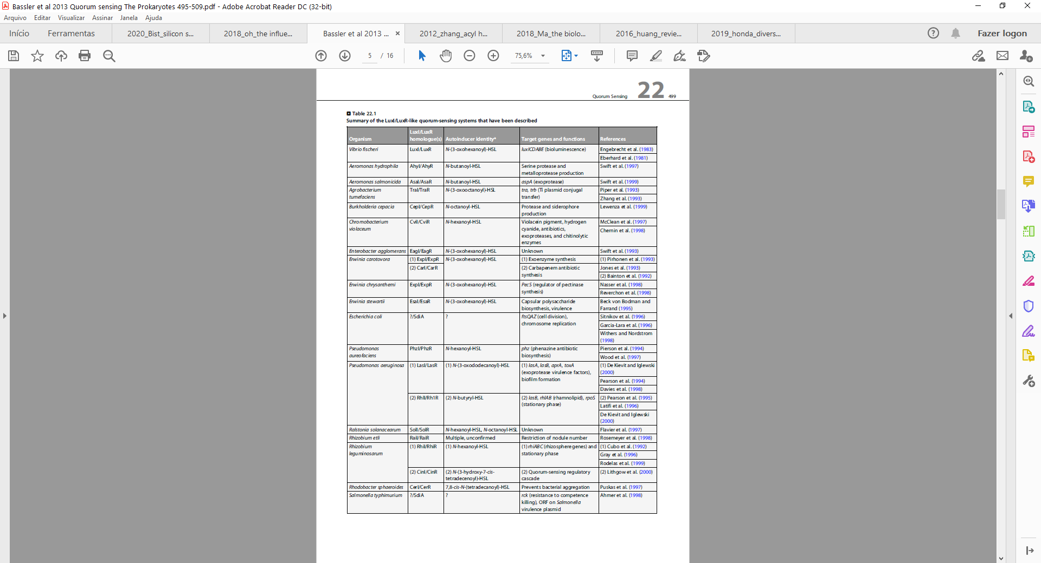

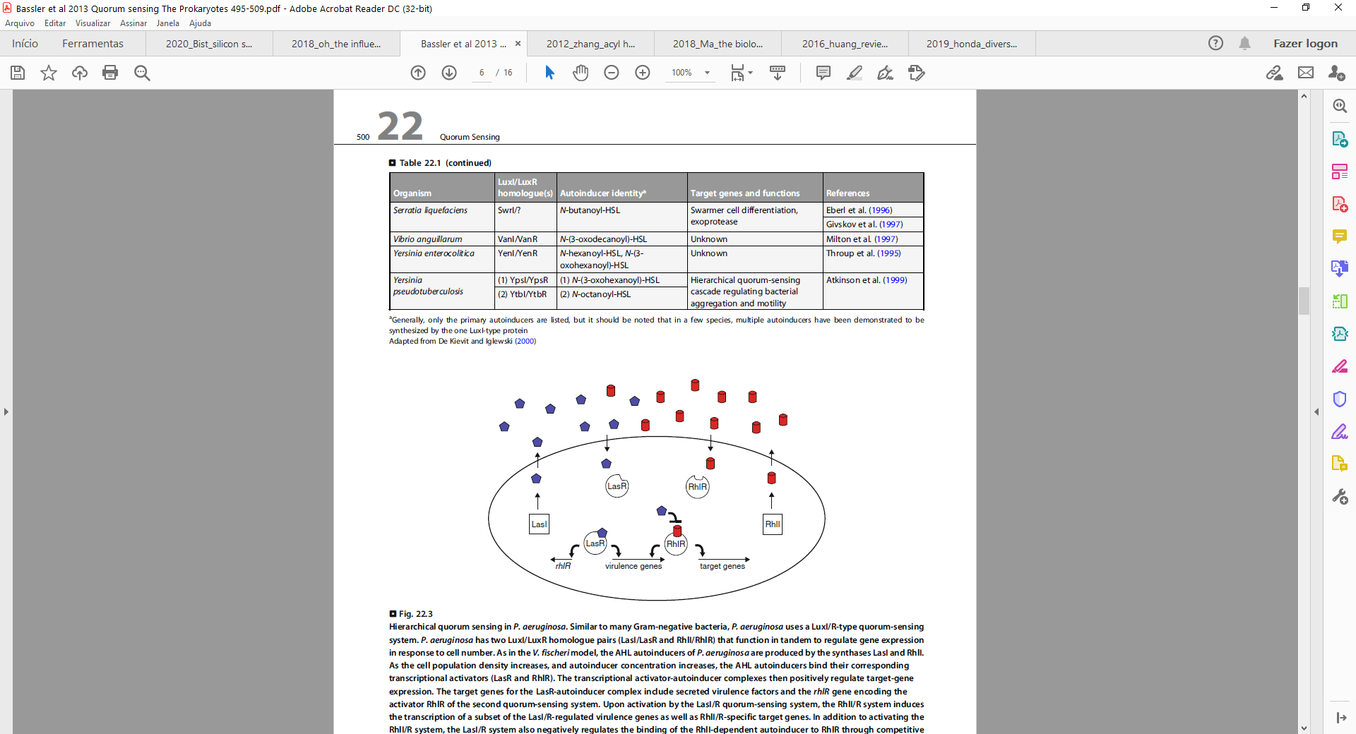

References

Chua, Kah-Ooi, et al. “In Silico Analysis Reveals Distribution of Quorum Sensing Genes and Consistent Presence of LuxR Solos in the Pandoraea Species.” *Frontiers in Microbiology*, vol. 10, 2019, p. 1758, doi:10.3389/fmicb.2019.01758.

Du, Qing, et al. “Metagenomic and Bioanalytical Insights into Quorum Sensing of Methanogens in Anaerobic Digestion Systems with or without the Addition of Conductive Filter.” *Science of The Total Environment*, vol. 763, 2021, p. 144509, doi:https://doi.org/10.1016/j.scitotenv.2020.144509.

Huang, Jinhui, et al. “Acyl-Homoserine Lactone-Based Quorum Sensing and Quorum Quenching Hold Promise to Determine the Performance of Biological Wastewater Treatments: An Overview.” *Chemosphere*, vol. 157, 2016, pp. 137–51, doi:https://doi.org/10.1016/j.chemosphere.2016.05.032.

Ng, Wai-Leung, and Bonnie L. Bassler. “Bacterial Quorum-Sensing Network Architectures.” *Annual Review of Genetics*, vol. 43, 2009, pp. 197–222, doi:10.1146/annurev-genet-102108-134304.

Rajput, Akanksha, et al. “SigMol: Repertoire of Quorum Sensing Signaling Molecules in Prokaryotes.” *Nucleic Acids Research*, 2015/10/20, vol. 44, no. D1, Oxford University Press, Jan. 2016, pp. D634–39, doi:10.1093/nar/gkv1076.

Reading, Nicola C., and Vanessa Sperandio. “Quorum Sensing: The Many Languages of Bacteria.” *FEMS Microbiology Letters*, vol. 254, no. 1, Jan. 2006, pp. 1–11, doi:10.1111/j.1574-6968.2005.00001.x.

Zhang, Guishan, et al. “Acyl Homoserine Lactone-Based Quorum Sensing in a Methanogenic Archaeon.” *The ISME Journal*, vol. 6, no. 7, 2012, pp. 1336–44, doi:10.1038/ismej.2011.203.